Javascript Assignments

1. Write JavaScript code that prompts the user to enter 10 names one at a time and store each name as an element of an array of size 10. The program then should determine how many names entered have a length greater than 5 and display the result.

2. Write JS code that initializes an array with 6 numbers ,the program then needs to find and display the average of all the numbers in array.

3. Create an array of five animals. Use a for loop to display the values stored in that array. Add two more animals to the end of that array. Sort the array and display the sorted array on the screen.

4. JavaScript: Create a simple shopping list program.

For the assignment you will have the following tasks:

1) Create an Array ............. var someArrayName = []

2) Complete the function code to Add an Item from the input box to the array.

3) Complete the function code to Remove The Last Item from the array.

4) Complete the function code to Remove The First Item from the array.

5) Complete the function code to Clear the array completely. Note this can be done by setting the array length to 0 using myArray.length = 0;

6) Complete the function code to Output the list to the screen.

5.  Calculate the area of a circle using the **Math** object. Use the toFixed() method to set the decimal places to two digits.

6.  create a new object and assign it 3 properties (first name, last name, and major). You will then complete the 3 functions for the buttons to display those properties. For this assignment you can just use alerts

# 7. Simple TODO app

Simple basic javascript TODO app

Screenshot:

[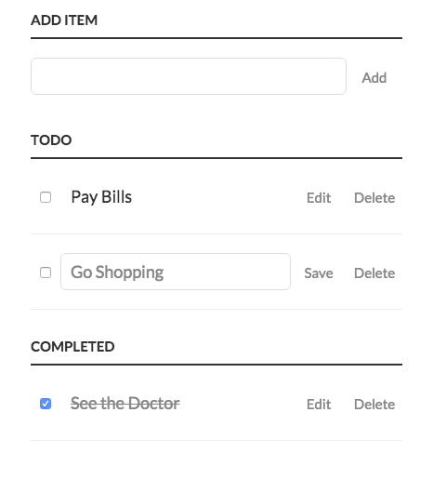](https://github.com/vivriticapital/javascript-assignments/blob/master/simple-todo-app/images/todo-js-basic.png?raw=true)

1. **Features:**

* Should be able to add a new Item
* List the existing Items (uncompleted)
* Should be able to edit and delete the existing Item
* Should be able to complete the Item
* List the completed Items